NEDI TECHNICAL DOCUMENT
The National Education Data Initiative (NEDI) data platform architecture and implementation approach are defined here, based on the current delivery context, available data sources, and the target operating model established within the server environment.
It is presented in two parts: an end-to-end view of how data flows through the platform and the tools used at each stage, followed by a detailed breakdown of each architectural layer, including its purpose, processes, and integration points.
This structure is intended to remove ambiguity, align implementation, and serve as a practical reference for delivery.
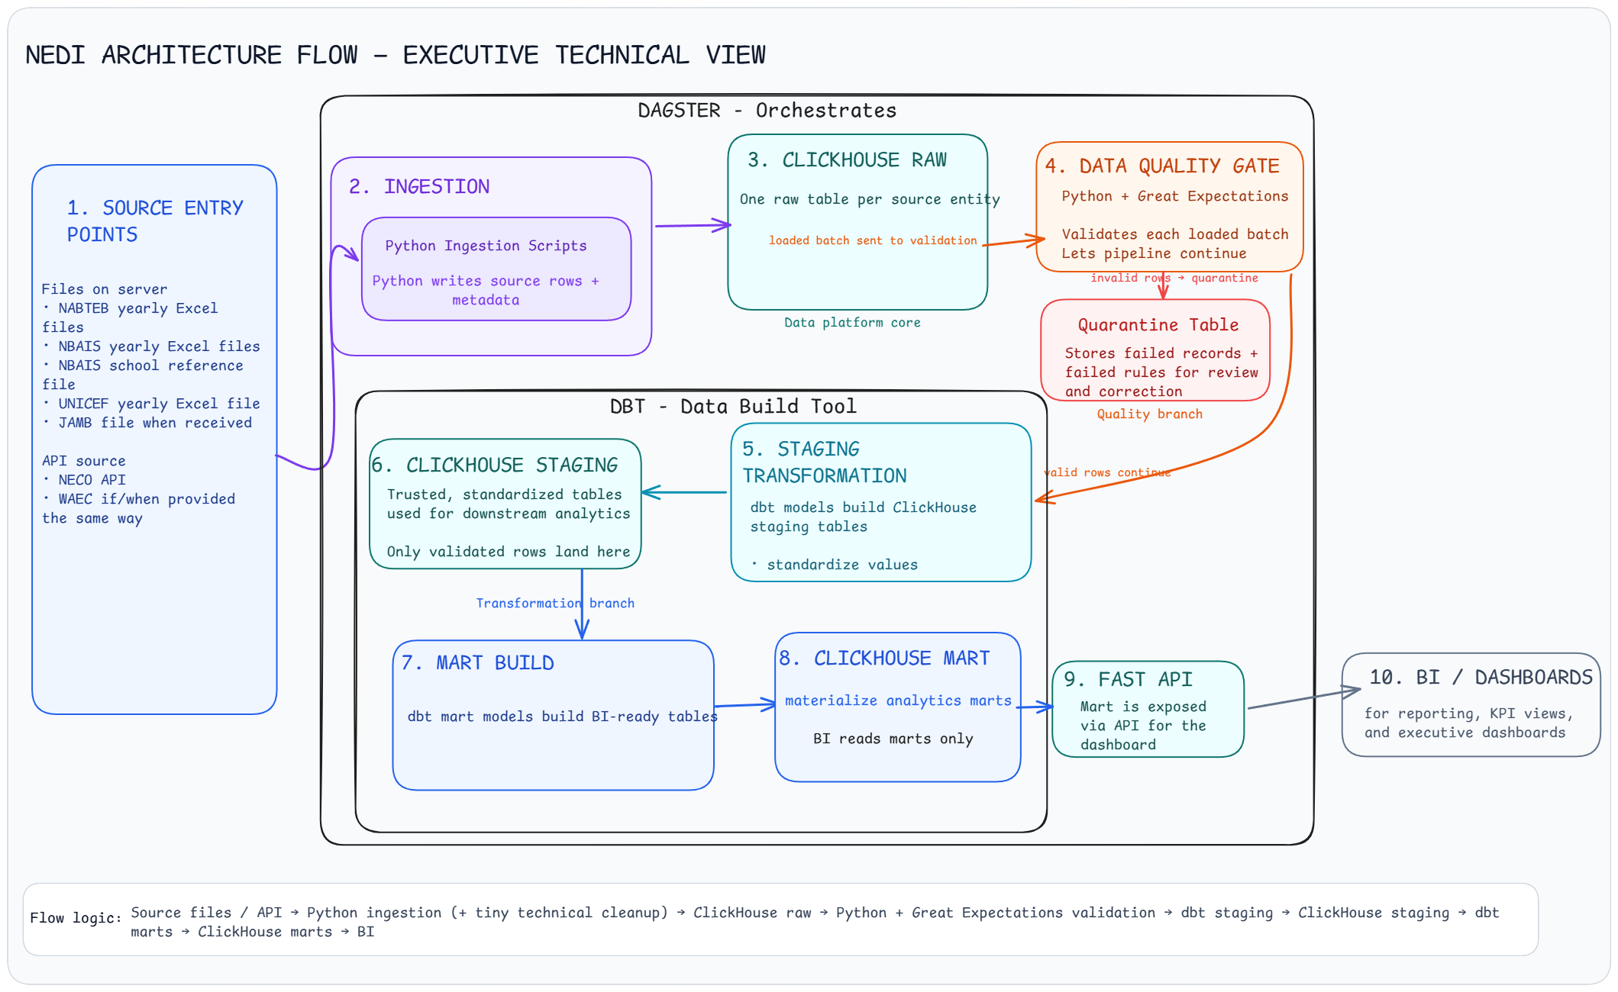

LAYER 1 & 2: Ingestion and Raw Layer
Data from source systems is ingested into the ClickHouse raw layer in a controlled, traceable, and repeatable way. As the first persisted storage layer, it preserves source data in a form that remains as close as possible to its original structure after ingestion.

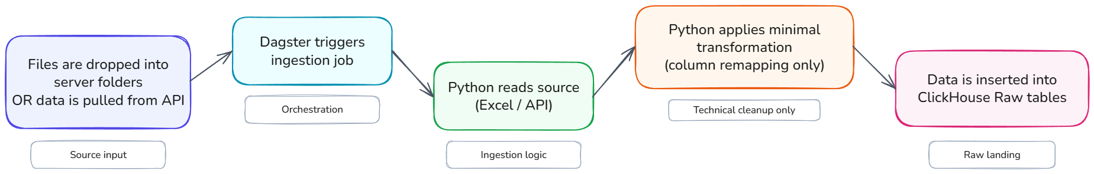
The raw layer is designed as one table per source entity, not one table per file and not one combined raw table. Each source lands in its own raw table, and new yearly deliveries are appended into those tables.
Raw tables in this layer
- neco_candidate_summary
- raw_waec_candidate_summary
- raw_nabteb_candidate_wide
- raw_nbais_candidate_wide
- raw_nbais_school_reference
- raw_jamb_admission_candidate
- raw_unicef_school_enrollment
Each raw table should contain ingestion metadata fields:
- load_id
- source_name
- source_year
- source_file_name
- ingested_at

Minimal transformations allowed in this layer
NABTEB
cand_no → candidate_number
cand_name → candidate_name
cand_add → candidate_address
dob → date_of_birth
examyear → exam_year
examtype → exam_type_code
exmtypdesc → exam_type_desc
centername → institution_name
ownership_ → ownership_type
school_sta → school_state
school_lga → school_lga
centre → exam_center_number
trad_typ → trade_type_code
tradename → trade_name

NBAIS
Candidate_No → candidate_number
Candidate_Name → candidate_name
Date_of_Birth → date_of_birth
Candidate_Address → candidate_address
Candidate_Type → candidate_type
Exam_Year → exam_year
Exam_Diet → exam_diet
Exam_Type → exam_type
Institution_Name → institution_name
Institution_Type → institution_type
Ownership_Type → ownership_type
School_State → school_state
School_LGA → school_lga
Exam_Center_Number → exam_center_number
Education_Pathway → education_pathway

NBAIS Schools Reference
NAME OF SCHOOL → school_name
SCHOOL ADDRESS → school_address
SCHOOL OWNERSHIP (PUBLIC/PRIVATE) → school_ownership_type
SCHOOL EMAIL OR PHONE NO. → school_contact
PRINCIPAL'S NAME → principal_name

JAMB
UTME Registration Number → utme_registration_number
Name of Candidate (First, Middle, Last) → candidate_name
Institution → institution_name
Year of Admission → year_of_admission
Programme of Study → programme_of_study
Mode of Admission → mode_of_admission
Disability Status of Candidate → disability_status

UNICEF
State → state
LGA → lga
Ward → ward
Type → school_level_group
School → school_name_raw
NewSchoolCode → new_school_code
Location → location
Ownership → ownership
School Type → school_type
P3_Male → p3_male
P3_Female → p3_female
P3_Streams → p3_streams
P5_Male → p5_male
P5_Female → p5_female
P5_Streams → p5_streams
JS2_Male → js2_male
JS2_Female → js2_female
JS2_Streams → js2_streams
SS2_Male → ss2_male
SS2_Female → ss2_female
SS2_Streams → ss2_streams

LAYER 3: Data Quality Gate Layer (Validation, Quarantine, Re-Processing)
1. Architecture
This layer controls what is allowed to move from fme_nedi_raw into downstream transformation.
It performs four functions:
- validates newly ingested raw records
- separates passed and failed records
- supports manual review where NEDI can assess the issue
- exports unresolved provider-owned issues back to source providers

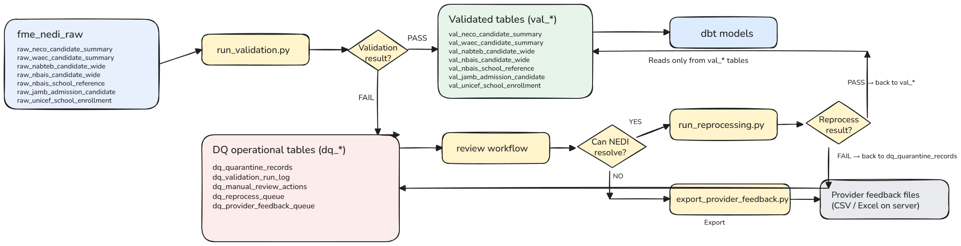

2. Tables in this Layer
2.1 Validated tables
Table | Description
val_neco_candidate_summary | Passed NECO candidate summary records
val_waec_candidate_summary | Passed WAEC candidate summary records
val_nabteb_candidate_wide | Passed NABTEB candidate records
val_nbais_candidate_wide | Passed NBAIS candidate records
val_nbais_school_reference | Passed NBAIS school reference records
val_jamb_admission_candidate | Passed JAMB admission candidate records
val_unicef_school_enrollment | Passed UNICEF school enrollment records

2.2 DQ (Data Quality) operational tables
Table | Description
dq_quarantine_records | Failed records awaiting review or escalation
dq_validation_run_log | Batch-level summary of each validation run
dq_manual_review_actions | Audit log of review decisions
dq_reprocess_queue | Manually resolved records waiting for revalidation
dq_provider_feedback_queue | Unresolved records queued for provider export

3. Core Columns
3.1 dq_quarantine_records
Column | Definition
dq_record_id | Unique identifier assigned when a record first enters quarantine
load_id | Original batch identifier
source_name | Source system name
source_table | Raw source table
source_file_name | Original file or extract name
source_year | Reporting or exam year
row_number_in_source | Original row number in source
failed_rule_name | Validation rule that failed
failed_column_name | Column that failed
failed_value | Value that caused failure
failure_reason | Plain explanation of failure
severity | Failure severity
quarantine_status | Current workflow state of the record (open, manual_review_pending, manual_review_in_progress, reprocess_pending, provider_feedback_pending, resolved)
review_route | manual_review or provider_feedback
review_comment | Internal reviewers note
provider_comment | Note to provider if escalated
quarantined_at | Timestamp record entered quarantine
reviewed_at | Timestamp record was reviewed
resolved_at | Timestamp record was resolved or escalated
raw_row_json | Full raw record as JSON

3.2 dq_validation_run_log
Column | Definition
validation_run_id | Unique validation run identifier
load_id | Batch identifier
source_name | Source system name
source_table | Raw table validated
validation_started_at | Start timestamp
validation_completed_at | End timestamp
rows_checked | Total rows checked
rows_passed | Total rows written to val_*
rows_failed | Total rows written to quarantine
validation_status | Run outcome

3.3 dq_manual_review_actions
Column | Definition
review_action_id | Unique review action identifier
dq_record_id | Quarantined record being reviewed
load_id | Original load id
source_name | Source system name
source_table | Source table name
reviewer_name | Reviewer
review_decision | Review result (resolved_for_reprocessing, escalated_to_provider)
review_comment | Internal review note
provider_comment | Provider-facing comment where needed
reviewed_at | Review timestamp

3.4 dq_reprocess_queue
Column | Definition
reprocess_id | Unique reprocesses item identifier
dq_record_id | Reference to quarantined record
original_load_id | Original batch id
source_name | Source system name
source_table | Source table name
reprocess_payload_json | Corrected record for revalidation
reprocess_status | Reprocess status (pending, passed, failed)
submitted_by | Reviewer who submitted it
submitted_at | Queue entry timestamp
completed_at | Reprocess completion timestamp

3.5 dq_provider_feedback_queue
Column | Definition
provider_feedback_id | Unique provider feedback item identifier
dq_record_id | Reference to quarantined record
load_id | Original batch id
source_name | Source system name
source_table | Source table name
source_file_name | Original file or extract name
source_year | Reporting or exam year
row_number_in_source | Original row number
failed_rule_name | Validation rule failed
failed_column_name | Column that failed
failed_value | Value that caused failure
failure_reason | Reason the record failed
internal_review_comment | Internal note explaining why it could not be resolved
provider_comment | Actionable note to provider
feedback_status | Export/process status (pending export, exported, sent_to_provider)
queued_at | Queue timestamp
exported_at | Export timestamp

3.6 val_* tables
Each validated table keeps:
- validated business columns for that source
- load_id
- source_name
- source_year
- source_file_name
- validated_at
These tables are the only input used by downstream dbt staging models.

LAYER 4: STAGING LAYER
Validated data is standardized into clean, consistent structures for downstream modelling. The staging layer operates only on approved records, preparing them for modelling, comparison, and aggregation.
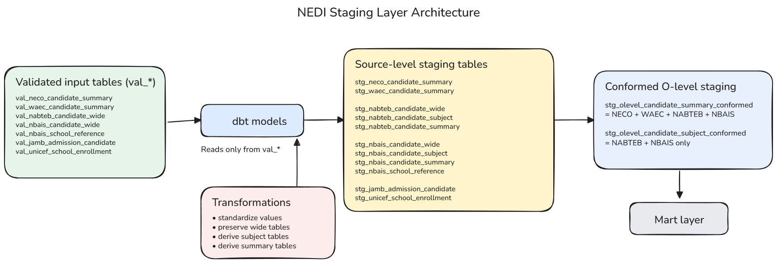

4.1. Source-level staging outputs
Source | Validated input | Staging outputs | Note
NECO | val_neco_candidate_summary | stg_neco_candidate_summary | Standardize summary fields and derive exam_year, exam_body
WAEC | val_waec_candidate_summary | stg_waec_candidate_summary | Same treatment as NECO
NABTEB | val_nabteb_candidate_wide | stg_nabteb_candidate_wide, stg_nabteb_candidate_subject, stg_nabteb_candidate_summary | Keep wide table, derive subject rows, derive candidate summary
NBAIS | val_nbais_candidate_wide | stg_nbais_candidate_wide, stg_nbais_candidate_subject, stg_nbais_candidate_summary | Keep wide table, derive subject rows, derive candidate summary
NBAIS School Reference | val_nbais_school_reference | stg_nbais_school_reference | Standardize school reference fields
JAMB | val_jamb_admission_candidate | stg_jamb_admission_candidate (contains candidate_match_key) | Standardize candidate, institution, programme, admission fields
UNICEF | val_unicef_school_enrollment | stg_unicef_school_enrollment | Standardize school/geography fields and derive selected totals

4.2. Subject-level transformation logic
Source | Wide structure | Subject-level output | Key rule
NABTEB | subject1/grade1 ... subject22/grade22 | one row per candidate per subject | subject slots are unpivoted into rows
NBAIS | one subject column per subject | one row per candidate per subject | blank grade = subject not written

4.3. Candidate summary derivation
Source | Summary table | Derived fields
NECO | stg_neco_candidate_summary | standard cleaned summary fields
WAEC | stg_waec_candidate_summary | standard cleaned summary fields
NABTEB | stg_nabteb_candidate_summary | total_credits, has_math_credit, has_english_credit, has_both_credits, olevel_pass_flag
NBAIS | stg_nbais_candidate_summary | total_credits, has_math_credit, has_english_credit, has_both_credits, olevel_pass_flag

4.4. Conformed O-level staging
Table | Sources included | Purpose
stg_olevel_candidate_summary_conformed (contains candidate_match_key) | NECO, WAEC, NABTEB, NBAIS | Main O-level candidate performance layer
stg_olevel_candidate_subject_conformed | NABTEB, NBAIS | Subject-level O-level analysis

4.5 Geography standardization
Source pattern | Rule
NECO / WAEC use state_code, lga_code | Map to standard state and LGA reference values
NABTEB / NBAIS / UNICEF use names | Normalize names and map to same standard geography reference
Output | All staging tables should carry standardized state and LGA values for cross-source reporting

Staging outputs to support this
- stg_geography_mapping_state
- stg_geography_mapping_lga
or one controlled geography reference used across staging models

4.6 Institution standardization and matching
Item | Decision
Institution sources | NABTEB, NBAIS, NBAIS school reference, UNICEF, JAMB
Resolution priority | reliable code first, otherwise normalized name + geography
Unresolved institutions | retain as flagged for review/mapping

Key institution inputs by source
Source | Institution fields
NABTEB | institution_name, exam_center_number
NBAIS | institution_name, exam_center_number
NBAIS School Reference | school_name, school_address, state, lga
UNICEF | school_name_raw, new_school_code, state, lga
JAMB | institution_name
Recommended staging support table
- stg_institution_reference

4.7 O-level pass rule
KPI | Rule
O-level pass | Credit in Maths + Credit in English + at least 3 other credits
Implementation | has_math_credit = 1 AND has_english_credit = 1 AND total_credits >= 5

4.8 Final staging outputs
Category | Tables
Source-level staging | stg_neco_candidate_summary, stg_waec_candidate_summary, stg_nabteb_candidate_wide, stg_nabteb_candidate_subject, stg_nabteb_candidate_summary, stg_nbais_candidate_wide, stg_nbais_candidate_subject, stg_nbais_candidate_summary, stg_nbais_school_reference, stg_jamb_admission_candidate, stg_unicef_school_enrollment, stg_olevel_candidate_match_bridge
Conformed staging | stg_olevel_candidate_summary_conformed, stg_olevel_candidate_subject_conformed

- stg_olevel_candidate_match_bridge
Column | Meaning
match_bridge_id | unique row id
olevel_candidate_key | candidate key from O-level side
jamb_candidate_key | candidate key from JAMB side
olevel_exam_body | NECO / WAEC / NABTEB / NBAIS
olevel_exam_year | exam year
jamb_admission_year | JAMB admission year
candidate_match_key | standardized linking key
match_method | how the match was made
match_confidence | HIGH / MEDIUM / LOW
matched_to_jamb_flag | 1 if matched
created_at | timestamp
Example
O-level
candidate_key | candidate_name | gender | exam_body | exam_year
101 | AHMAD USMAN | MALE | WAEC | 2023
JAMB
candidate_key | candidate_name | gender | year_of_admission
9001 | AHMAD USMAN | MALE | 2024
Bridge output:
match_bridge_id | olevel_candidate_key | jamb_candidate_key | candidate_match_key | match_method | match_confidence
1 | 101 | 9001 | AHMADUSMAN_MALE | EXACT_NAME_GENDER_YEAR_WINDOW

LAYER 5. DATA MART
The mart layer is the final analytical layer where cleaned and standardized staging data is transformed into business-ready datasets for reporting and decision-making. It is built using dbt on top of the fme_nedi_staging tables and materialized into fme_nedi_marts. This layer is structured around business questions, not source systems, meaning each mart is designed to answer a specific analytical need.
The mart layer contains KPI-ready datasets, aggregated views, and reporting-friendly structures that are consumed directly by BI tools.
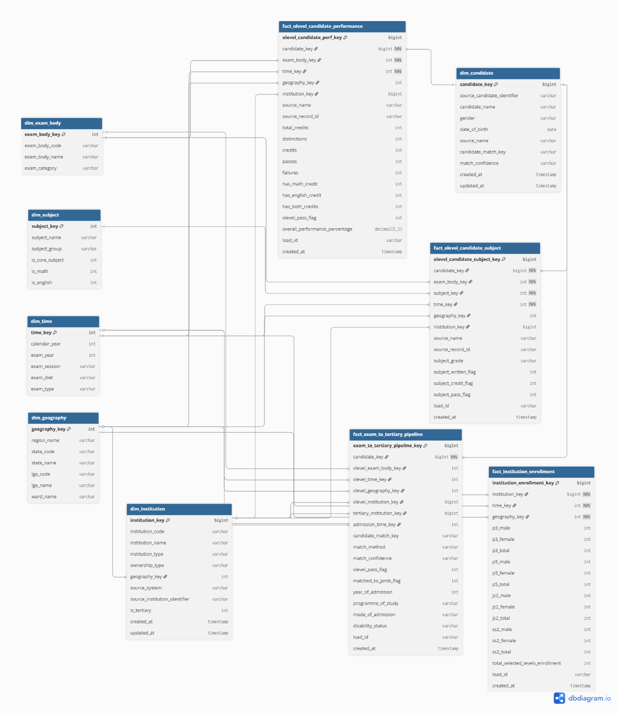

5.1 Core mart model
Fact tables
Fact table | Grain | Main source(s) | Purpose
fact_olevel_candidate_performance | one row per candidate per exam body per year | stg_olevel_candidate_summary_conformed | Main O-level KPI fact
fact_olevel_candidate_subject | one row per candidate per subject per exam body per year | stg_olevel_candidate_subject_conformed | Subject-level O-level analysis
fact_exam_to_tertiary_pipeline | one row per matched O-level candidate to JAMB admission record | stg_olevel_candidate_summary_conformed, stg_jamb_admission_candidate | O-level to tertiary transition
fact_institution_enrollment | one row per institution per year | stg_unicef_school_enrollment | School-level enrollment analysis

Dimension tables
Dimension | Purpose
dim_candidate | Candidate identity and profile attributes
dim_exam_body | O-level exam body reference
dim_subject | Subject reference for subject fact
dim_time | Time reference
dim_institution | Institution reference across school and tertiary contexts
dim_geography | Standardized state/LGA reference

KPI Availability Matrix
The table below shows the availability status of every KPI and chart across all dashboard sections based on currently available data sources.
Status key:
- Available — Fully answerable with current data
- Partial — Some data available but incomplete (e.g. limited class levels or missing exam body)
- Blocked — Cannot be answered until a future data source is onboarded

General Overview
KPI / Chart | Status | Current Source | Blocked By
Total Enrolled Students | Partial | UNICEF (P3, P5, JS2, SS2 only) | Full UNICEF data
Total Pre/Primary Students | Partial | UNICEF (P3, P5 only) | Full UNICEF data
Total Formal Secondary Students | Partial | UNICEF (JS2, SS2 only) | Full UNICEF data
Total O-Level Students | Partial | NECO, NABTEB, NBAIS | WAEC
Total Teachers | Blocked | — | Teacher data source
Average Primary Learners per School | Partial | UNICEF | Full UNICEF data
Primary Level Pupil-Teacher Ratio | Blocked | — | Teacher data source
Direct Transition Funnel | Partial | NECO, NABTEB, NBAIS (O-Level only) | WAEC, JAMB, NELFUND
Student Loss by Stage | Partial | O-Level stage only | WAEC, JAMB, NELFUND
Drop-off by State | Partial | O-Level stage only | WAEC, JAMB, NELFUND
STEMM & Non-STEMM Matriculated Trend | Blocked | — | JAMB, NELFUND
Loan Applications vs Loans Disbursed | Blocked | — | NELFUND
Adult & Non-Formal Education Enrollment | Available | NBAIS (Almajiri) | —

Access & Coverage
KPI / Chart | Status | Current Source | Blocked By
Total Basic Enrollment | Partial | UNICEF | Full UNICEF data
Total Formal Primary Students | Partial | UNICEF (P3, P5 only) | Full UNICEF data
Total JSS1 Students | Blocked | — | Full UNICEF data (JS1 not provided)
Total SS1 Students | Blocked | — | Full UNICEF data (SS1 not provided)
Total O-Level Students | Partial | NECO, NABTEB, NBAIS | WAEC
Total Schools | Available | UNICEF | —
Total Public Schools | Available | UNICEF | —
Total Private Schools | Available | UNICEF | —
Almajiri Count | Available | NBAIS | —
Average Primary Learners per School | Partial | UNICEF | Full UNICEF data
Public vs Private School Count | Available | UNICEF | —
Public vs Private Student Count | Partial | UNICEF | Full UNICEF data
Student Count by Gender | Partial | UNICEF | Full UNICEF data
Enrollment Trend by Class Level | Blocked | — | Multi-year UNICEF data
Enrollment by Key Entry Level and State | Partial | UNICEF | Full UNICEF data
Enrollment by Key Entry Level and Gender | Partial | UNICEF | Full UNICEF data
Learners per Classroom | Blocked | — | Classroom/infrastructure data
Computers vs Enrollment Size | Blocked | — | Infrastructure data
Infrastructure Score | Blocked | — | Infrastructure data

Teacher Capacity
KPI / Chart | Status | Current Source | Blocked By
Total Teachers | Blocked | — | Teacher data source (from UNICEF)
Total Male Teachers | Blocked | — | Teacher data source
Total Female Teachers | Blocked | — | Teacher data source
Overall Pupil-Teacher Ratio | Blocked | — | Teacher data source
Pupil-Teacher Ratio by School Type | Blocked | — | Teacher data source
Pupil-Teacher Ratio by School Level | Blocked | — | Teacher data source
Teaching Qualification charts | Blocked | — | Teacher data source
Qualified vs Unqualified Teacher Rate | Blocked | — | Teacher data source
Qualification Trend Over Academic Session | Blocked | — | Teacher data source

Direct Transition
KPI / Chart | Status | Current Source | Blocked By
O-Level Candidates | Partial | NECO, NABTEB, NBAIS | WAEC
UTME Participants | Blocked | — | JAMB
Admitted Students | Blocked | — | JAMB / NELFUND
Matriculated Students | Blocked | — | JAMB / NELFUND
Learners with >2 Year Admission Gap | Blocked | — | JAMB / NELFUND
Median Time to Matriculation | Blocked | — | JAMB / NELFUND
Total SS3 Students | Blocked | — | Full UNICEF data
Transition by Zone / State / Gender | Partial | O-Level stage only | WAEC, JAMB, NELFUND
Drop-off by Zone / State / Gender | Partial | O-Level stage only | WAEC, JAMB, NELFUND
Performance
KPI / Chart | Status | Current Source | Blocked By
WAEC Pass Rate | Blocked | — | WAEC
NECO Pass Rate | Available | NECO | —
NABTEB Pass Rate | Available | NABTEB | —
NBAIS Pass Rate | Available | NBAIS | —
UTME Qualifying Rate | Blocked | — | JAMB
Admission Rate | Blocked | — | JAMB / NELFUND
Matriculation Completion Rate | Blocked | — | JAMB / NELFUND
WAEC Pass Rate by Gender / Zone / State | Blocked | — | WAEC
NECO Pass Rate by Gender / Zone / State | Available | NECO | —
NABTEB Pass Rate by Gender / Zone / State | Available | NABTEB | —
NBAIS Pass Rate by Gender / Zone / State | Available | NBAIS | —
Four-Year Exam Performance Trend | Partial | NECO, NABTEB, NBAIS (3 years) | WAEC

Policy Impact
KPI / Chart | Status | Current Source | Blocked By
Total Matriculated Learners | Blocked | — | JAMB / NELFUND
STEMM Share | Blocked | — | JAMB / NELFUND
Non-STEMM Share | Blocked | — | JAMB / NELFUND
Number of Loans Disbursed | Blocked | — | NELFUND
Programme Mix STEMM vs Non-STEMM | Blocked | — | JAMB / NELFUND
STEMM vs Non-STEMM by Gender | Blocked | — | JAMB / NELFUND
STEMM vs Non-STEMM by Zone / State | Blocked | — | JAMB / NELFUND
Matriculation by Discipline | Blocked | — | JAMB / NELFUND
Top 10 Courses by Matriculated Students | Blocked | — | JAMB / NELFUND
Loan Applications vs Loans Disbursed | Blocked | — | NELFUND
Approved/Disbursed Loans by Institution Type | Blocked | — | NELFUND
Approved/Disbursed Loans by Discipline | Blocked | — | NELFUND

